CBA South-East annual conference 2015:
‘Life in the Mesolithic and new perspectives on the Mesolithic/Neolithic transition’
Student bursary application form
The CBA South-East student bursary has been generously financed by the Prehistoric Society. It provides financial assistance to students currently studying for an undergraduate or post-graduate university degree in archaeology or a related discipline. The bursaries are limited and will be awarded on a competitive basis. Preference will be given to those students whose current research has a focus relevant to the conference theme or are intending to embark upon such research.

The award is for £30.00 and is intended to cover the cost of the ticket and subsidise travel. Award winners must purchase a ticket and register their place at the conference before the booking deadline, and the bursary will be awarded at the conference. It is not a requirement of the reward, but students are encouraged to present a poster of their research at the conference. Please contact Dr Martyn Allen m.g.allen@reading.ac.uk for details.

Full name

Affiliation/Current university

Current degree course

Email address

Preferred telephone no.

Please add a short statement that describes your research

Registration fee £
Travel costs £
Accommodation £
Subsistence £
Total £
Estimated expenditure

Signature Date
(If submitting by email please type your name or add a scanned signature)

Please return this form via email to Dr Martyn Allen at m.g.allen@reading.ac.uk or by post to 101 St Peter’s Gardens, Wrecclesham, Farnham, Surrey, GU10 4QZ

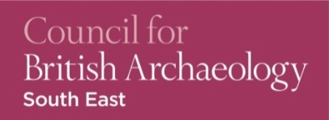
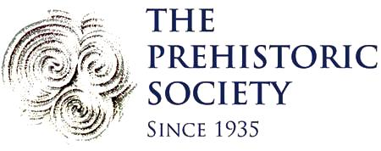
The bursary award deadline is
Friday 30th October 2015

