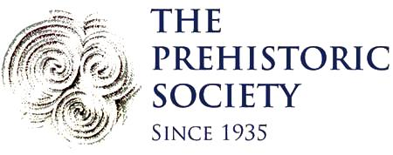
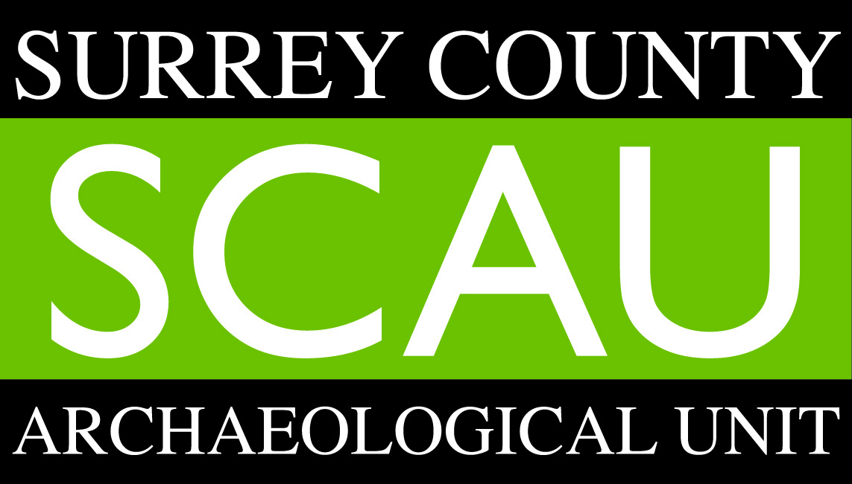
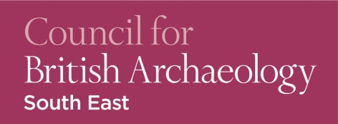

CBA South-East Conference:
Life in the Mesolithic and new perspectives on the Mesolithic/Neolithic transition
Surrey History Centre, Woking: Saturday 14th November 2015

TICKET FORM
CBA South-East members - £16.00
Non-members - £20.00

Name:

No. tickets required: CBASE members non-members
Names of other applicants:

£
Total cost:

Primary email address:
Please note that confirmation of booking and further conference details will be sent via email
To pay by cheque
Please print out the completed form and send with a cheque made out to ‘CBA South East’ to:

Dr Martyn Allen
101 St Peter’s Gardens
Wrecclesham
Farnham
Surrey
GU10 4QZ
To pay by online banking or direct from your local branch*
Please email your completed form to Martyn Allen at m.g.allen@reading.ac.uk

Make your payment to our account using the following details:

Payee name: CBA SOUTH EAST
Payee account number: 0 0 7 8 4 8 5 8
Payee sort code: 3 0 - 9 6 - 8 3

*For us to associate your payment with your booking reference when paying online, please make your Payee Reference your full name alongside CBASE conference, e.g. 'Joe Bloggs CBASE conference'

