From: Paul Tritton, Hon. Press Officer
Email: paul.tritton@btinternet.com
Telephone 01622 741198
ISSUED 28 MAY 2015

KENT HISTORY AWARDS TOP £35,000
Kent’s local, social and family history enthusiasts have until 31 March 2016 to apply for the next tranche of grants to be awarded by the Kent Archaeological Society from its Allen Grove Local History Fund.
Amounts of up to £1,000 are offered annually to individuals, groups, organizations and students to help cover the cost of research, publications, exhibitions and other projects focused on the county’s history and heritage.
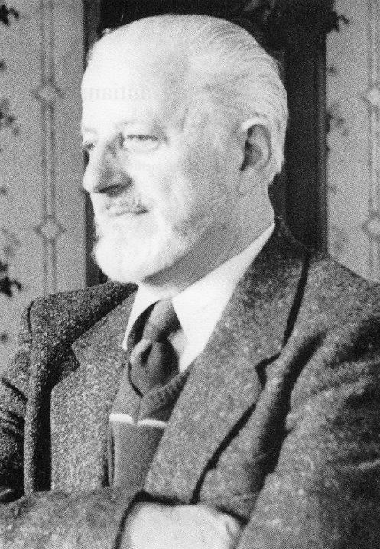
Allen Grove (pictured above) was one of Kent’s most eminent historians of his generation. He was Curator of Maidstone Museum from 1948 to 1975, Hon. Curator of the KAS for 26 years (and its President in 1987/88) and Chairman of the Kent History Federation for eight years.
When he died in 1990 he left £26,000 from the proceeds of the sale of his house to the KAS, with instructions that the society should invest the legacy and distribute the interest in ways that would promote the enjoyment of Kent's local history.
The first grants were made in 1994 and the total amount awarded since then now exceeds £35,000, mainly to support the publication of books and booklets but also for displays in heritage centres, for oral history projects, and for establishing archives and research centres.
Application forms can be downloaded from www.kentarchaeology.org.uk or obtained by email from allengroveadmin@kentarchaeology.org.uk or by post from the KAS c/o 8 Woodview Crescent, Hildenborough, Tonbridge, Kent TN11 9HD (please enclose a s.a.e.).
The 2014 and 2015 recipients were:
Boughton Malherbe History Society £500 to cover the cost of printing a second book on the history of the parish, following the publication of ‘Boughton Malherbe A Journey Through Time’ in 2010. A free copy of each book is given to every household in the parish and profits from sales are donated to local good causes.
Brenchley and Matfield Local History Society £180 towards buying acid-free sleeves and boxes to store original documents.
Folkestone and District Family History Society £340 for display folders for family histories of the men named on Shepway’s war memorials. A folder will be donated to the parish in which each memorial is located, and to Folkestone Library and the Town Hall. The society has nearly finished researching the family histories of 1,500 men.
Harrietsham History Society £300 for a digital voice recorder. The society is following-up its recent book ‘Harrietsham in Old Photographs and Postcards’ with an oral history project. Said Peter Brown, the society’s chairman: ‘We are talking to some of the very elderly residents of our village to obtain details of their lives in Harrietsham whilst they are still able to recount this’.
Horsmonden Historical Society £500 towards publishing a book containing interviews with 35 villagers.
Kent Gardens’ Trust £500 towards printing and editing costs for a book on five Kent gardens associated with Lancelot Brown (‘Capability Brown’), the renowned 18th century landscape artist.
Lucas Reynolds of Sutton-at-Hone, Dartford £125 towards researching and writing a social history of Sutton Place, Sutton-at-Hone.
Maidstone Museum £1,000 for further work on researching, cataloguing, conserving and displaying the ‘Boughton Malherbe hoard’ 346 Bronze Age artefacts, including swords, knives, scabbards and spears, recovered from a field by metal detectorists Wayne Coomber and Nick Hales from Headcorn.
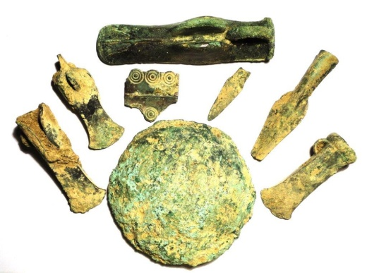
Part of the ‘Boughton Malherbe hoard’. (Maidstone Museum)
Christopher Pickvance of Wickhambreaux £500 for dating an unrecognized group of incised gothic chests and two other medieval chests.
Plaxtol Local History Group £500 towards the purchase of photographs from the Royal Commission for Historical Monuments and English Heritage, and printing costs, for a revised edition of a book on medieval timber-framed houses in the Manor of Wrotham.
Shoreham and District Historical Society £200 towards research for a book on Shoreham residents in WW1.
Smarden Local History Society £450 towards publishing transcriptions of oral recordings of local residents’ memories in a 28-page colour illustrated book. Said hon. secretary, Yvonne Bonham Miller: ‘Recording the memories going back to the 1920s and 1930s, began in the 1970s. These tape recordings have now been transcribed, edited and digitized by volunteers in our heritage centre. The publication draws from work undertaken by the society and will be of interest to many visitors to our centre, the relatives and descendants of those indentified in the book, and also to a wider audience, including Smarden School pupils.’
Note to editor: for JPEGs of the above images, email paul.tritton@btinternet.com

