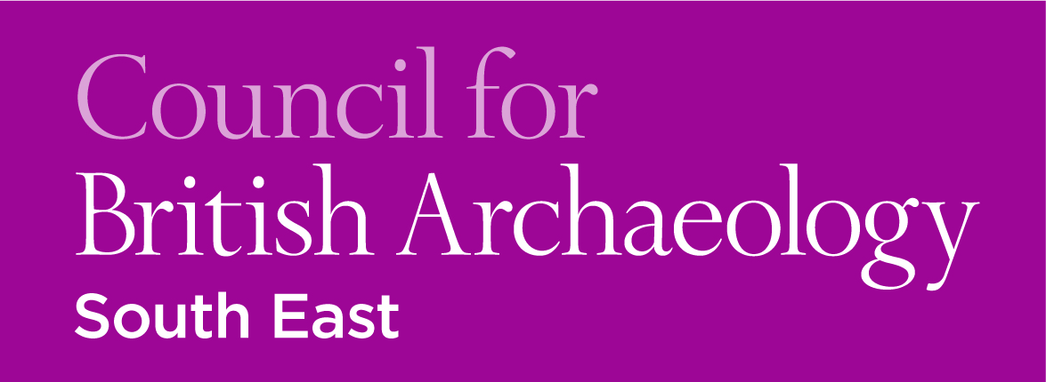 CBA South-East Workshops:
2016 Pottery Training Series

TICKET FORM
CBA South-East members – £15.00 per day-course
Non-members – £20.00 per day-course
(Special Offer – 5 courses for the price of 4)

Name:

No. tickets required: CBASE member non-member

Courses booked for: Intro – Tonbridge – 16/01

Intro – Petworth – 30/01

Prehistoric – Petworth – 06/02

Roman – Leatherhead – 12/03

Medieval – Leatherhead – 23/04

Post-Medieval – Tonbridge – 07/05
£
Total cost:

Primary email address:
Please note that confirmation of booking and further event details will be sent via email
To pay by cheque
Please print out the completed form and send with a cheque made out to ‘CBA South East’ to:

Dr Anne Sassin
101 St Peter’s Gardens
Wrecclesham
Farnham
Surrey
GU10 4QZ
To pay by online banking or direct from your local branch*
Please email your completed form to A.E. Sassin (events@cbasouth-east.org)

Make your payment to our account using the following details:

Payee name: CBA SOUTH EAST
Payee account number: 0 0 7 8 4 8 5 8
Payee sort code: 3 0 - 9 6 - 8 3

*For us to associate your payment with your booking reference when paying online, please make your Payee Reference your full name alongside CBASE pottery workshop, e.g. 'Joe Bloggs CBASE pottery workshop'

