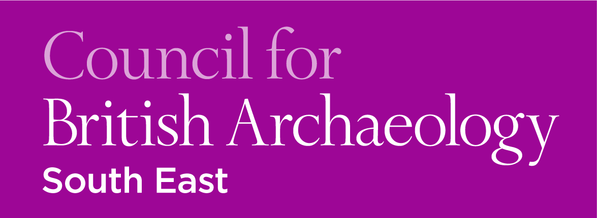 CBA South-East Workshops:
2018 Training Series

TICKET FORM
CBA South-East members – £20.00 per day-course
Non-members – £25.00 per day-course

Name:

No. tickets required: CBASE member non-member

Courses booked for:

LiDAR – 20/01 Coins 1 – 10/02

Coins 2 – 24/03 CBM – 21/04

£
Total cost:

Primary email address:
Please note that confirmation of booking and further event details will be sent via email
To pay by cheque
Please print out the completed form and send with a cheque made out to ‘CBA South East’ to:

Dr Anne Sassin
101 St Peter’s Gardens
Wrecclesham
Farnham
Surrey
GU10 4QZ
To pay by online banking or direct from your local branch*
Please email your completed form to A.E. Sassin (events@cbasouth-east.org)

Make your payment to our account using the following details:

Payee name: CBA SOUTH EAST
Payee account number: 0 0 7 8 4 8 5 8
Payee sort code: 3 0 - 9 6 - 8 3

*For us to associate your payment with your booking reference when paying online, please make your Payee Reference your full name alongside CBASE workshop, e.g. 'Joe Bloggs CBASE workshop'

