From: Paul Tritton, Hon. Press Officer
Email: paul.tritton@btinternet.com
Telephone 01622 741198
ISSUED 14 SEPTEMBER 2015

Step out into the Middle Ages in Canterbury in April

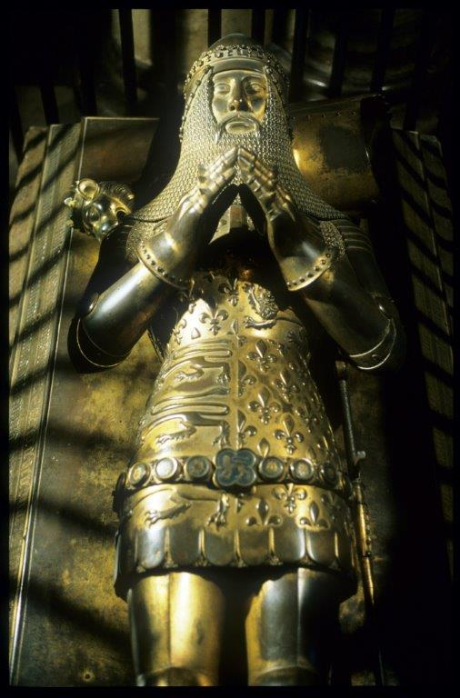
Copyright: Dean and Chapter of Canterbury Cathedral

A weekend of events celebrating the Middle Ages will be held in Canterbury on 1 – 3 April 2016.

Twenty eminent scholars and historians will host a series of lectures on the most eventful era in Britain history, and lead guided walks to explore places associated with the city’s colourful medieval past.

Said Dr Sheila Sweetinburgh of Canterbury Christ Church University, who will take visitors on an exploration of St John’s Hospital, founded c.1080 by Archbishop Lanfranc: ‘In the Middle Ages, Canterbury was internationally important as the site of St Thomas Becket’s’ shrine and was on the main highway between London and mainland Europe, traversed by kings, knights and merchants.

‘Consequently it is an ideal setting in which to make recent research readily accessible to a wide audience, which will be given access to new interpretations, ideas and knowledge covering medieval topics from manuscripts studies to war and politics’.

The weekend is being sponsored by the Kent Archaeological Society, the Friends of Canterbury Archaeological Trust (members of either can buy tickets to the various events at concessionary rates) and The William and Edith Oldham Charitable Trust, and organized by the Centre for Research in Kent History and Archaeology (based at Canterbury Christ Church University) and Canterbury Cathedral Archives and Library.

The speakers will include David Starkey (on Henry VII), Richard Gameson (on The Gospels of St Augustine), Louise Wilkinson (on England’s ‘five forgotten princesses’, the daughters of King Edward 1 and Eleanor of Castille), Nicholas Vincent (on Relics: Blood, Bones and Becket’s Head) and Michael Jones, who will discuss his recent research on the Black Prince, whose tomb is one of Canterbury Cathedral’s most iconic monuments.

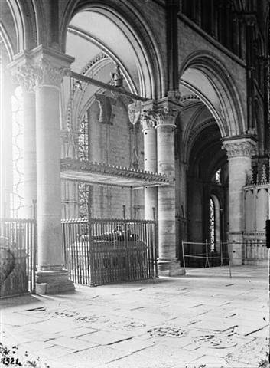
The Black Prince, whose tomb is pictured above in an archive photograph, will be the subject of one of the lectures
during the Canterbury Medieval Weekend.
(Kent Archaeological Society/Catharine Weed Barnes Ward Collection)
Top of previous page: the effigy on the Black Prince’s Tomb.
(Copyright: Dean and Chapter of Canterbury Cathedral)
There will be tours of Canterbury Cathedral Library (led by Karen Brayshaw), St Mildred’s Church (Paul Bennett), St John’s Hospital (Dr Sheila Sweetinburgh), the Westgate (Richard Eales) and the Poor Priests’ Hospital (Paul Bennett).

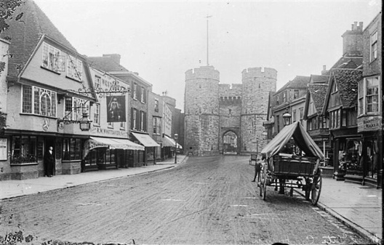
Above: an archive photograph of the Westgate, one of the buildings
on the Canterbury Medieval Weekend tour itinerary.
(Kent Archaeological Society/Catharine Weed Barnes Ward Collection)

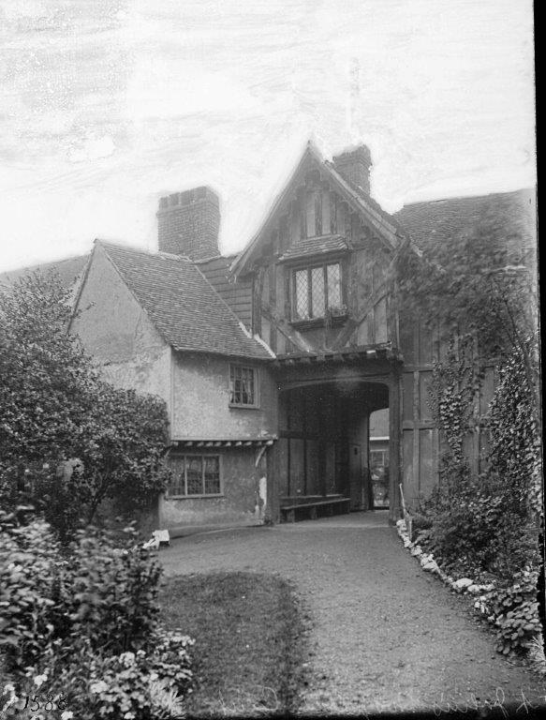
Above: an archive photograph of St John’s Hospital, one of the buildings
on the Canterbury Medieval Weekend tour itinerary.
(Kent Archaeological Society/Catharine Weed Barnes Ward Collection)
The weekend will conclude with a wide-ranging analysis on ‘Medieval Horizons’ by Ian Mortimer, author of A Time-traveller’s Guide to Medieval England. For full details visit http://www.canterbury.ac.uk/medieval-canterbury

