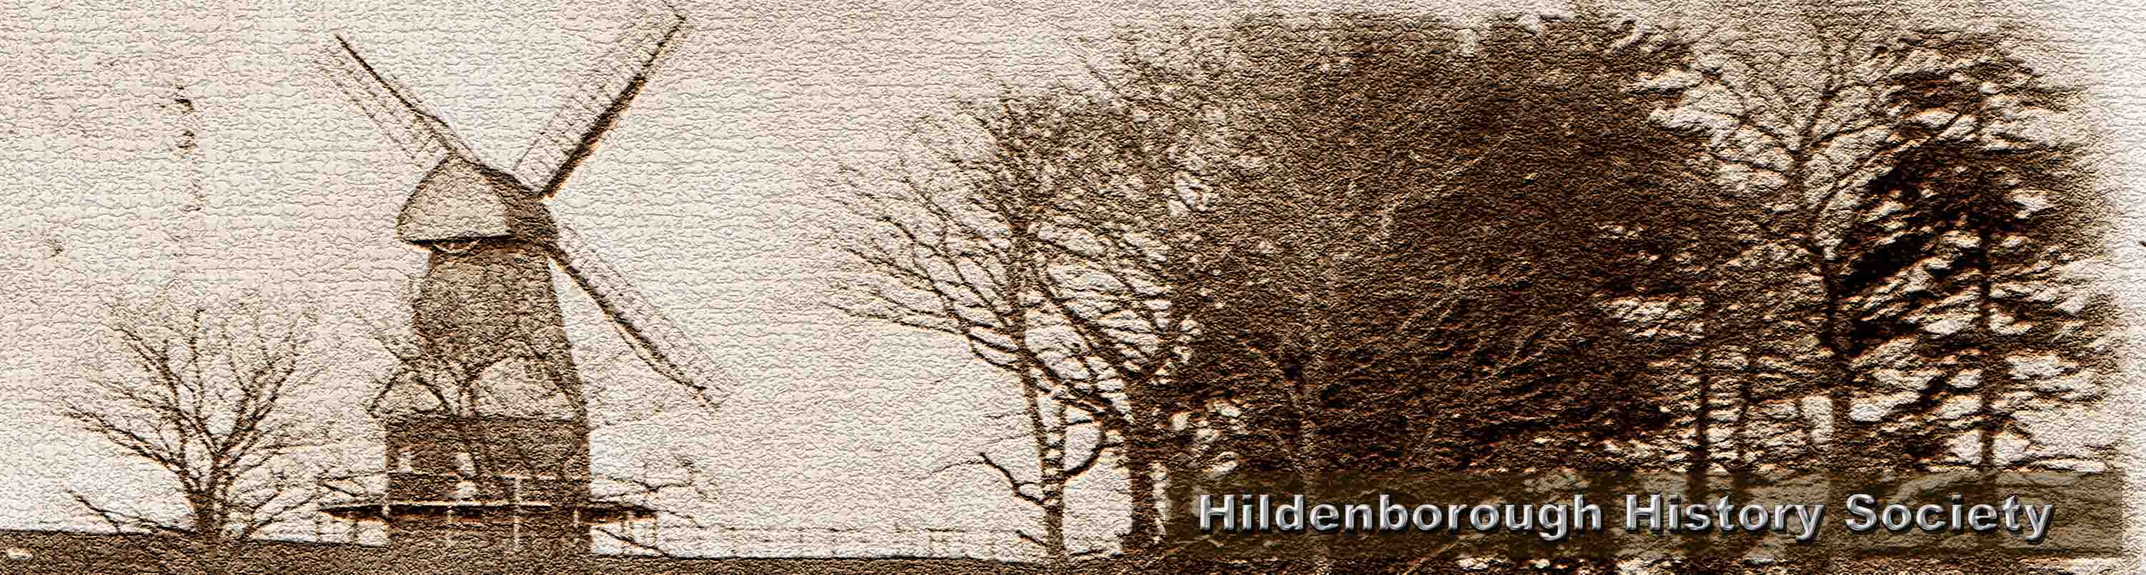

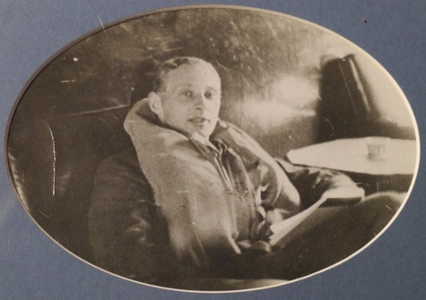
On Sunday, 27th October, 1940 at 8.30 a.m., a Spitfire MkII flown by Pilot Officer John Mather, 66 Squadron Gravesend, crashed and burned out on land to the rear of the Half Moon public house in Hildenborough killing the pilot.

In 1972, P7539's engine was recovered by Malcolm Pettit, a local amateur aeronautic archaeologist. The engine was found at a depth of 15 feet.

As this year is the 75th anniversary of the Battle of Britain and also, on October 27th, the anniversary of Pilot Officer Mather's death, Hildenborough History Society in conjunction with Jill and Alan Mackie, the landlords of the Half Moon public house, would like to erect a memorial plaque at the Half Moon to commemorate the supreme sacrifice made by this pilot.
On 25th October from 1.30pm there will be a ceremony to unveil the plaque at the Half Moon. The unveiling will be carried out by Wing Commander Andy Simpson, a Trustee of the Battle of Britain Memorial Trust assisted by the Rev Tim Saiet, who will give a blessing.

There will be a number of Second World War vehicles and other mementoes on display outside and inside the pub.
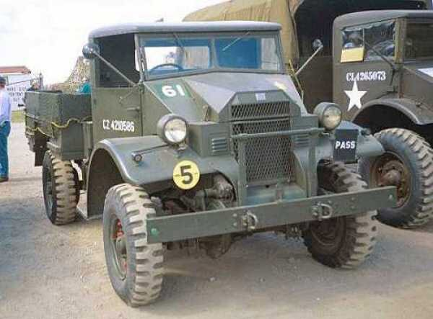
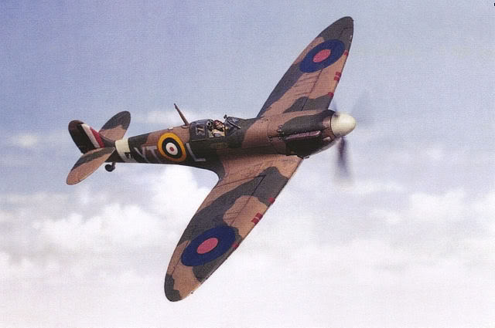

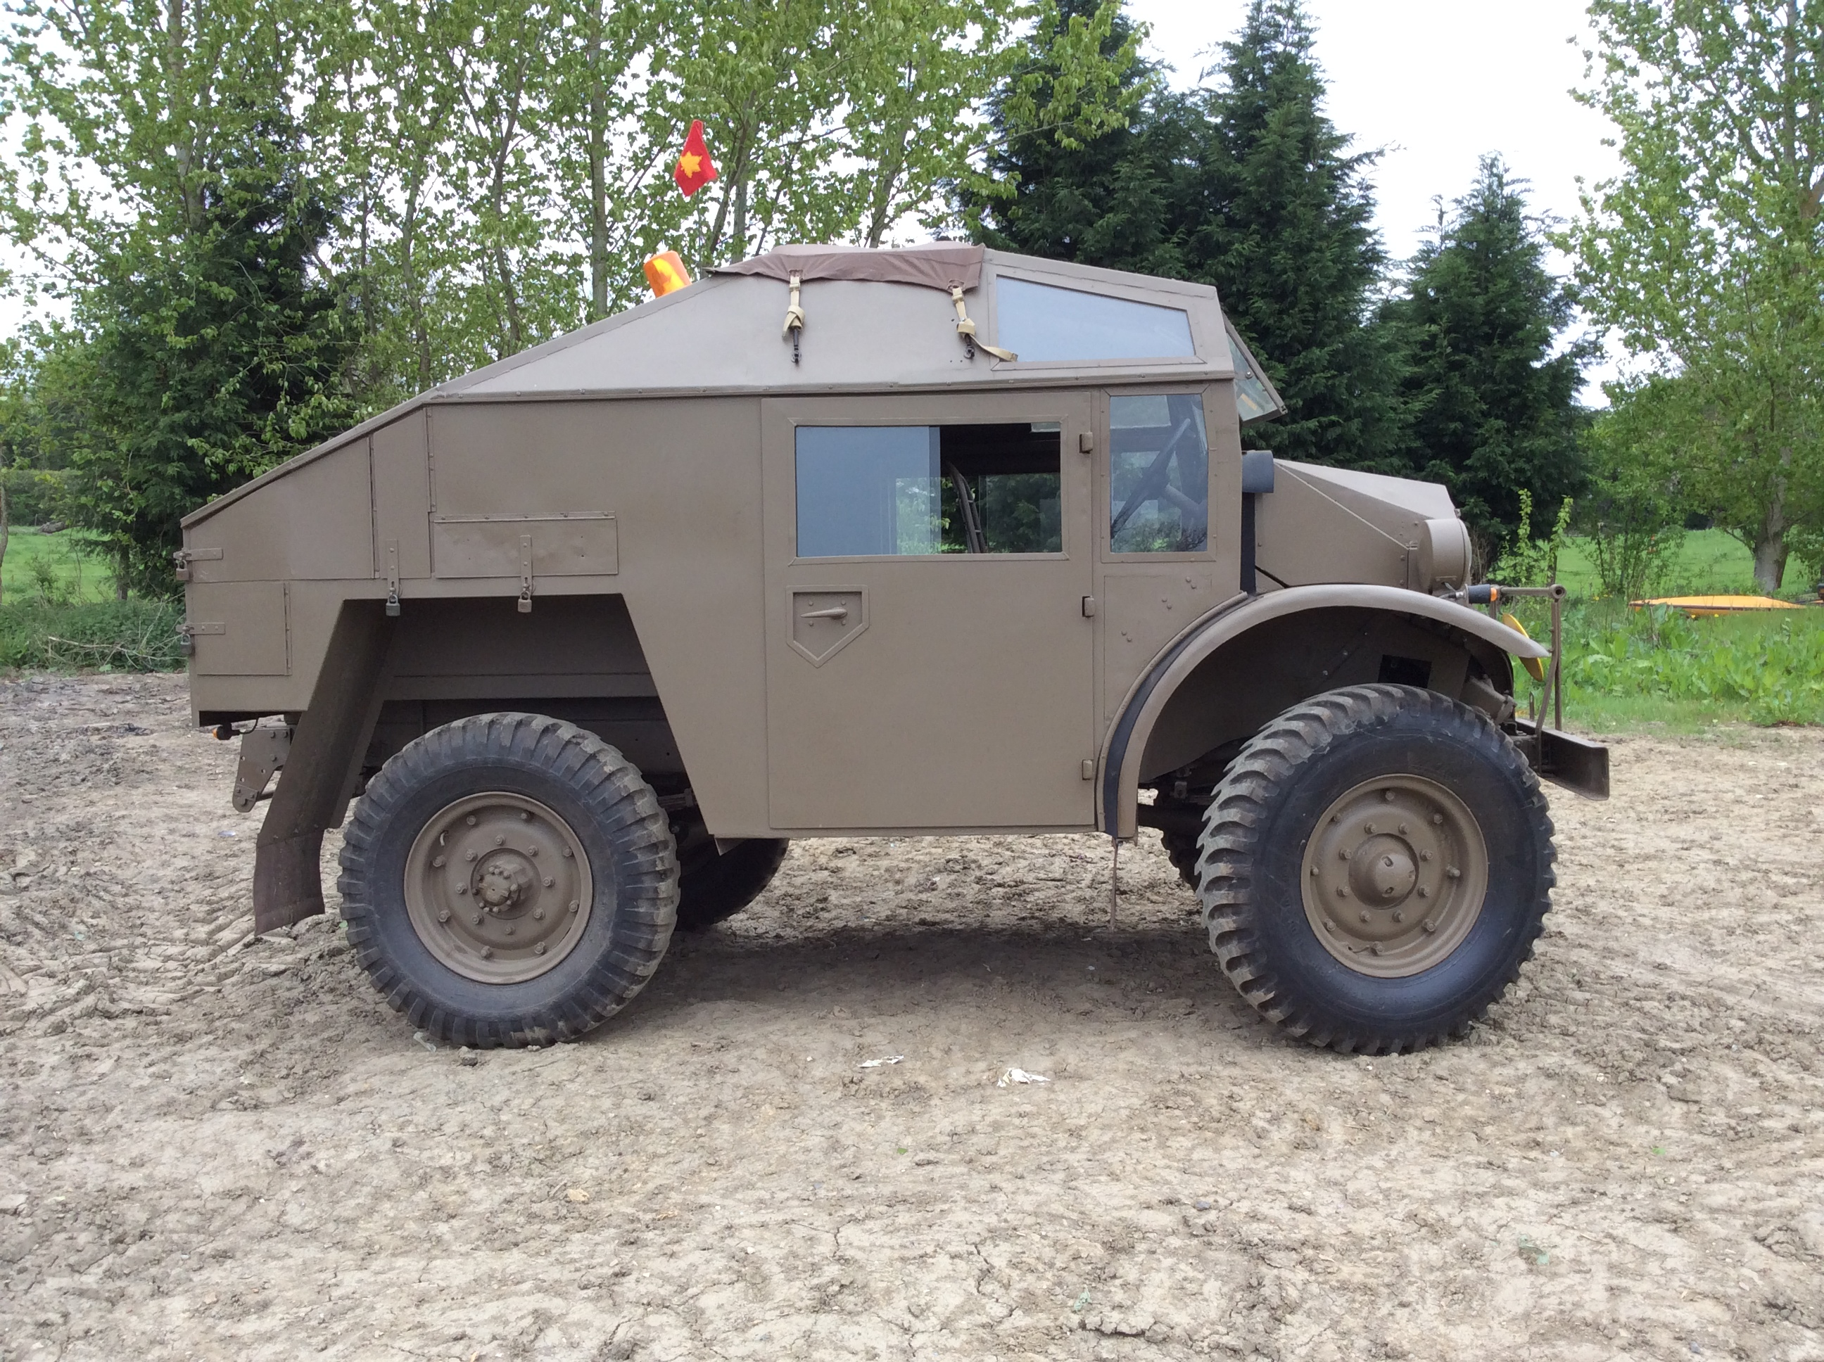
Half Moon pub, Hildenborough
25th October, from 1.30pm

Timetable of events
13.30 WW2 vehicles assemble in pub car park.
13.45 Boys Brigade band march in to pub car park.
13.55 Welcome to Wing Commander Andrew Simpson and brief history.
14.00 Unveiling ceremony by Wing Commander Andrew Simpson.
14.05 Blessing and dedication by Rev. Tim Saiet, followed by last post, minutes silence and then reveille.
14.10 Flypast by the Kent Spitfire by the kind auspices of Peter Monk. (Weather permitting)
14.15 Refreshments available in pub.

For a fuller history of John Mather, please see the Hildenborough History Society website…
http://hildenboroughhistorysociety.weebly.com/john-romney-mather-spitfire-pilot.ht

