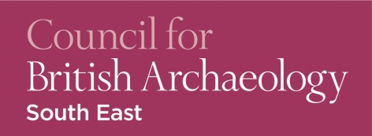

CBA South-East Conference 2016:
Pots, Palaces, Parks: Archaeology in the South East AD 1000-1700
Recital Room, Sevenoaks School, Kent: Saturday 19th November 2016

This day conference brings together presentations from community archaeology projects and academic research, revealing new discoveries and fascinating insights into the medieval and post-medieval period of south-east Britain. The talks exhibit the variety of methods and techniques, both innovative and traditional, now being used to shed light on sites and landscapes across the region, spanning over 700 years of history.

Arrival, registration, and coffee 10.15

Dr Martyn Allen (Chair, CBA South-East) 10.45
Introduction to the day
Nathalie Cohen (National Trust) 11.00
National Trust sites in Kent and Sussex: archaeology at Winchelsea, Bodiam and Knole
Mike Brace (University of Winchester) 11:30
Some of the story of St Mary Magdalen leprosy hospital, through the pottery
Richard Savage (Surrey Archaeological Society) 12.00
Excavations at Woking Palace, Surrey

Lunch and posters 12.30
CBA South East Annual General Meeting 13:15

Andy Mayfield (Kent County Council) 13.45
LiDAR, landscapes, and community archaeology at Randall Manor
Andy Margetts (Archaeology Southeast (UCL) and University of Exeter) 14:15
‘The Hayworth’, herds and husbandry

Coffee 14.45

Anne Bone (South Downs National Park) 15:15
Secrets of the High Woods—community archaeology in the South Downs National Park
Dr Amanda Richardson — Keynote speaker (University of Chichester) 15:45
Leaps and bounds: deer parks and fallow deer in constructions of English national identity from the 16th to the early 18th century

Close 16:15

Tickets
£16.00 for CBA South-East members and students, £20.00 for non-members
For further details and booking information, please visit our website at
http://www.cbasouth-east.org/events/cbase-annual-conference/
or email the organiser, Victoria Owen, studentrep@cbasouth-east.org

