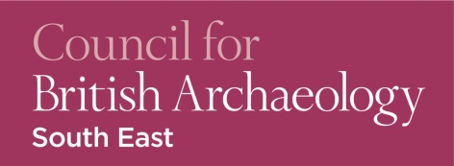

Joint Annual Conference

Kent Archaeological Society & Council for British Archaeology South East

Archaeological Perspectives on Links between the South East and the Continent

Saturday 2nd November 2019
Rutherford College, University of Kent at Canterbury CT2 7NX

9.30 – 10.00 | Coffee and registration
10.00 – 10.10 | Welcome & Introduction
10.10 – 10.45 | Sophie Adams | Rolling up The Sleeve and getting down to business -Investigating the production and deposition of Bronze Age bronzes across the channel
10.45 – 11.20 | Michael Walsh | Pudding Pan Shipwreck
11.20 – 11.30 | Questions
11.30 – 11.50 | Coffee
11.50 – 12.25 | Jo Ahmet | On the edge of Europe – a discussion of British, Continental and Mediterranean finds out of context
12.25 -13.00 | Leonie Hicks | Norman Landscapes & Connections
13.00- 13.10 | Questions
13.10 – 14.20 | Lunch & CBA SE AGM
14.20 – 14.55` | Murray Andrews | Continental Connections: cross-channel coin flows in the late middle ages
14.55 – 15.30 | Gustav Milne | “Wrecked off the Kentish Flats: the Gresham Ship” summarising the discovery, recovery and research of an armed Elizabethan merchantman, built in AD 1574, but lost some thirty years later
15.30 – 16.00 | Tea
16.00 – 16.10 | Questions
16.10 – 16.50 | Steve Willis | “Fair stood the wind for France” vignettes of our region through time
16.50 – 17.00 | Closing remarks

KAS /CBA SE Conference –Archaeological Perspectives on Links between the South East and the Continent - Booking form Saturday 2nd November 2019
Name of Delegate(s):…………………………………………………………………………………………………….

Address for tickets:………………………………………………………………………………………………………

……………………………………………………………………………………………………………………………

Tel No:…………………………………Email (Block capitals please):………………………………………………….
KAS Member YES / NO CBA Member YES/NO
Tickets £25 each (£20 KAS & CBA Members; £10 students). Please make cheques payable to Kent Archaeological Society and send with this tear off slip to: Mrs Shiela Broomfield, Membership KAS, 8 Woodview Crescent, Hildenborough, Tonbridge, Kent TN11 9HD (Please enclose a SAE). Further enquiries: email: membership@kentarchaeology.org.uk Tel: (01732) 838698.

