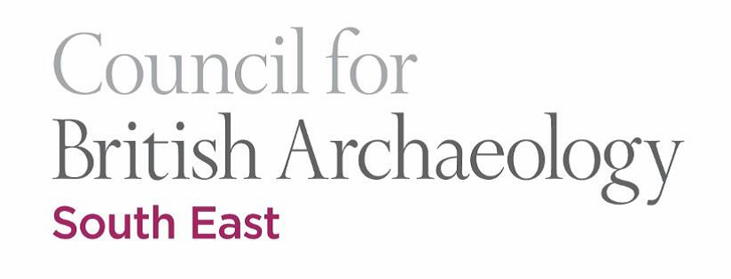

Grant Fund

Terms and Guidance notes

CBA South East (CBA-SE) is one of several regional groups affiliated to the Council for British Archaeology and is an independent charity.

CBA-SE brings together people with enthusiasm for archaeology (whether as general interest, an active pastime, or as a career). Kent, Surrey and Sussex are counties rich in archaeological landscapes, sites and historic buildings. Our interests cover all periods from prehistory to the present day and include industrial and maritime archaeology. CBA-SE arranges lectures, field visits, guided walks, study days and conferences and takes an active role in preserving and enhancing our heritage.

Funds are raised by subscriptions from our members and donations from the activities listed above. CBA-SE aims to generate a surplus of funds over its day-to-day funding and reserve requirements.

The Trustees of CBA-SE feel that the current surplus and any surplus in future years should be spent as grants within the south east region. The amount will be determined by the Trustees on a year by year basis following the financial year end.

The objectives of CBA South East are:

- To advance the study and practise of archaeology
- To promote the education of the public in such archaeology
- To conduct and/ or communicate the results of relevant research
- To advance pubic understanding and care of the historic environment

Who is eligible?

Any individual, local group, or Society working within the CBA-SE region is eligible to apply. We also would consider match funding as part of larger projects.

- Applications must demonstrate that they meet one or more of the aims stated above.
- Applications must be for projects undertaken in the South-East area.
- Applications must have a regional value.
- Applications should, where relevant, make reference to available research.

We can help with hire of equipment, support of excavation costs, specialist artefact analysis, radio-carbon dating, illustrations, outreach, etc.

We have also created a specific Young Archaeologists’ grant scheme which is open to YACs (Young Archaeologists Clubs), Museum clubs or other groups working with young people and who are looking for funding to support outreach and education projects or activities.

Applicants should normally ask for grants of up to £1000, but the upper limit is not set in stone and each application will be decided upon a case by case basis. For our Young Archaeologists’ grant scheme, we normally consider £200 the limit of the grant scheme, but may consider larger amounts.

CBA-SE funded components of projects should normally be completed within one year of the award being made (ie funded work is finished and a note submitted to the CBA-SE newsletter).

The Group will not fund:

- Individual general study costs or associated costs
- Part projects where future funds are essential for the project to continue, unless demonstrated that those funds will be available
- Travel costs to events or sites under the Young Archaeologists’ grant scheme

How to Apply:

Download the application form from our website and submit it, with the required information by email to the CBA South East Grants Officer at john.funnell@brightonarch.org.uk. We suggest that you also download and retain these terms and guidance notes.

Applications can be submitted anytime during the year but they will only be considered at two committee meetings, in October and April. The deadline for receipt of applications to go in for the October meeting is October 1st and, for the April, April 1st. This is a change that applies from October 2022.

The Evaluation Process:

Applications will be judged by the CBA-SE committee on how well they fulfil the aims of CBA-SE and that they have met with the criteria on the application form. If a committee member has links with the applicant or project under consideration, they shall not participate in the decision-making process. CBASE reserves the right to ask for additional information in support of any application.

The committee will endeavour to make a decision within 8 weeks of receiving the application. The decision of the committee will be final.

Payments:

CBASE will make funding available at its discretion dependent upon the individual application. This could be:
- Interim payments
- Payment upon sight of a receipt(s) (ie for equipment)
- Sight of pro-forma invoices(s) (ie for publications, deposits etc)

Successful Applicants will be required:
- To ensure the project/or a component of a project is completed within one year of receiving the award (unless a later date is agreed with the CBA-SE committee)
- To submit an evaluation report within one year of receiving the award
- To provide a short report for inclusion in the CBA-SE newsletter and website
- To acknowledge CBA-SE’s grant contribution in any publicity or printed material

CBASE reserves the right to reclaim part of an or any award where these conditions are not met.

Council for British Archaeology South East Region Charity Number 1047378

